# **UI and Interface Design**

# **HUD:**



Figure 1 - In game UI.

This was the initial design for the HUD. The circle would display the currently equipped weapon/ability and the bar represented player health. Another pitched idea was that the player would start reverting back to a figurine when they lose health, so that the player had a more visual and implicit way of telling how close they were to death, similar in concept to the blood splatters on the screen in some FPS games such as Call Of Duty.

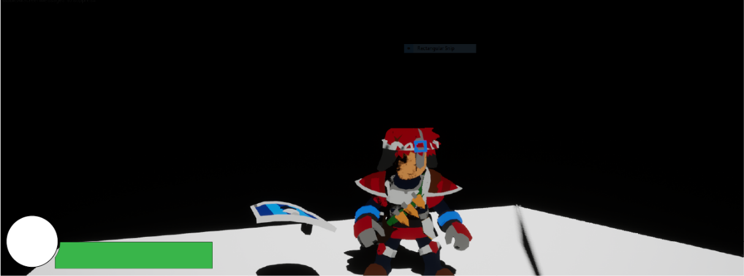

Figure 2 - Basic HUD design example

As this is all the information that the player needs to know during gameplay, this is all that is required from the HUD. However, we may add additional elements later as the game evolves.

# **Main Menu:**

For the main menu, the initial idea was to use a render target and scene capture actor, to use part of the environment as the background of the UI. This would show the player the sort of game to expect and has worked well in other games such as Plague Tale: Innocence and Borderlands 2, both of which use a unique environment for the Main Menu UI.

Figure 3 – The main menu.

Menu design will will consist of 3 buttons that will either start the game, navigate to the game’s options or quit the application. we will make the UI look more refined using Abode Illustrator later.

# **Save Select**

Similarly to the menu, we will use a render target, but we’ll a spline track to move the scene capture component to a new space in the world to change the background. The game will allow for up to three game saves.

Figure 4 - The save select menu.

# **Pause Menu:**

The pause menu will have multiple options available. The buttons will do the same to the main menu buttons, except the quit button will take the player back to the level select menu as opposed to exiting the application.

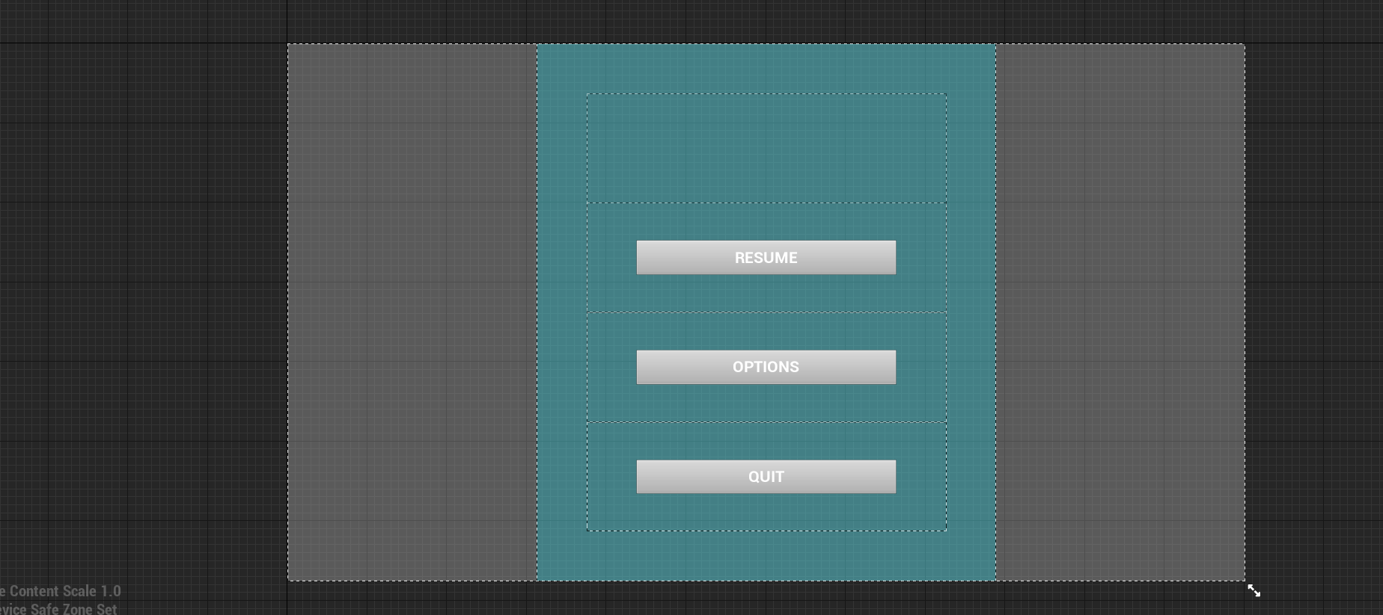

Figure 5 - The pause menu.

# **Level Select**

This is an outline for the level select menu. The white image will display an image of the level, while the buttons on the sides will switch the currently selected level to the adjacent levels. The leader board displays the best times for the level, based on saved data, and will display them along with the names of the slots. The buttons underneath the image will be to play the level and to go back to the save slots menu.

Figure 6 - The level select menu.

# **Level Complete**

This is an outline for the end level screen. It displays the information from the level that players can use to measure their progress and compare their skills to other players.

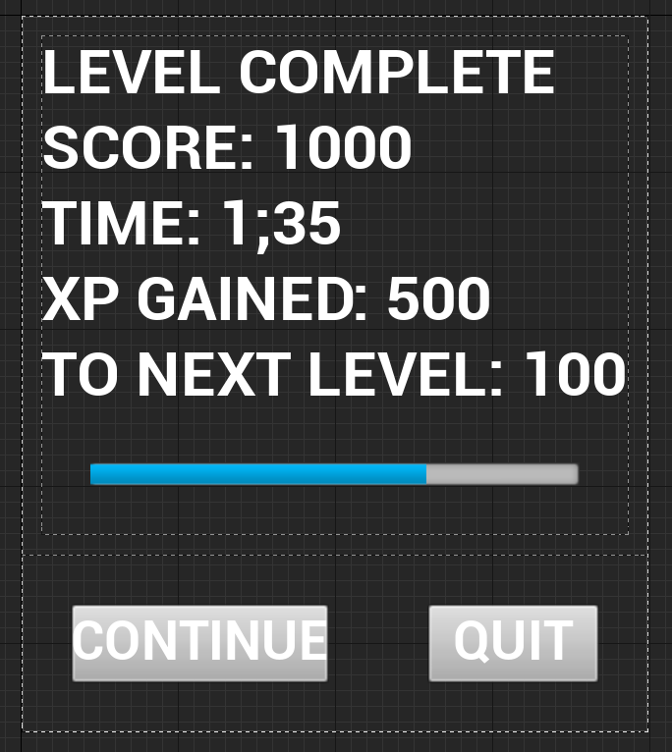

Figure 7 - Level completion UI.

# **Enemy Popup**

This is a concept for the popup that will appear next to an enemy when they are first encountered. It will display the enemy’s name very prominently, with a short description of them, including a good tactic to use against them.

Figure 8 - Enemy UI

# **Death Screen**

This is a basis for the “You Died!” screen. It will be overlaid onto the game in the state where the player died. The team took inspiration from Dark Souls, but this will visually evolve into our own idea as the game is developed.

Figure 9 – The death screen

# **Radial Menu**

This is the base for the radial menu for selecting weapons. We have the important information displayed to the player, such as their health and current weapon. We’re displaying the health in the weapon select as the scythe can refill the player’s health, and potentially showing XP to show the player how close they are to the next level and provide incentive to play more skilfully. Although the XP is a stretch goal for the team, we have planned ahead to include it in case we do decide to implement it.

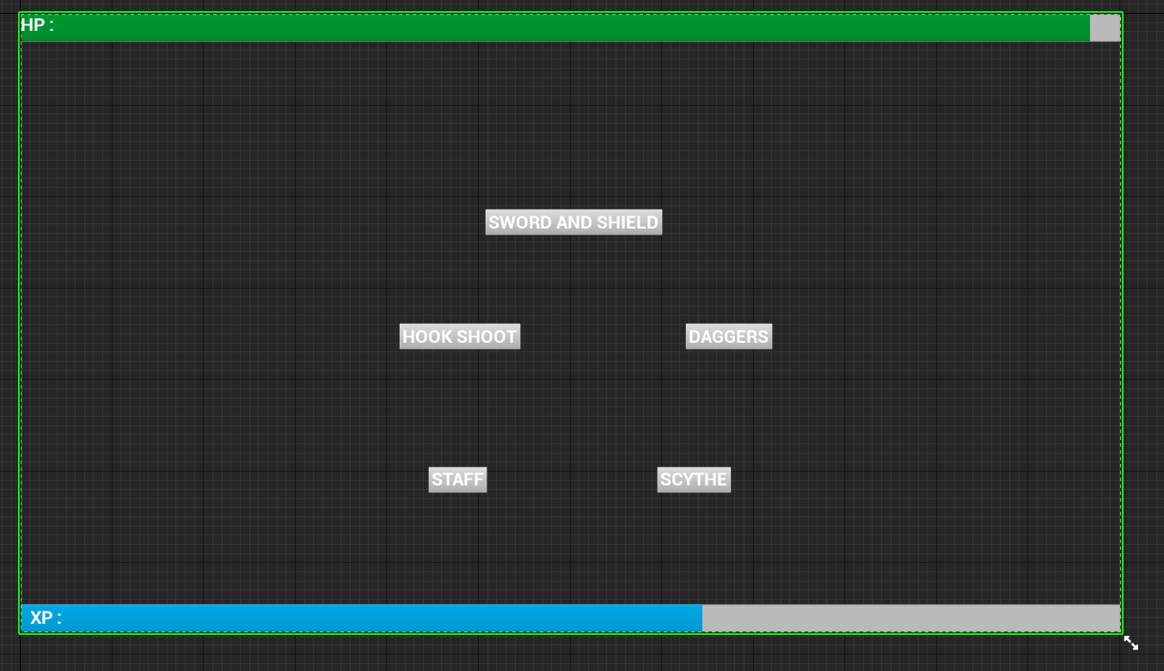

Figure 10 - The radial select screen.